AWS Database Migration Service

AWS Database Migration Service allows we to migrate data from a source database to a target database. During a migration, the service tracks changes being made on the source database so that they can be applied to the target database to eventually keep the two databases in sync. Although the source and target databases can be of the same engine type, they don’t need to be.
The possible types of migrations are:
1. Homogenous migrations (migrations between the same engine types)
2. Heterogeneous migrations (migrations between different engine types)

- At a high level, when using AWS DMS a user provisions a replication server, defines source and target endpoints, and creates a task to migrate data between the source and target databases.

A typical task consists of three major phases:

- The full load
- The application of cached changes
- Ongoing replication.

- The full load
During the full load, data is loaded from tables on the source database to tables on the target database, eight tables at a time (the default).
- The application of cached changes
While the full load is in progress, changes made to the tables that are being loaded are cached on the replication server; these are the cached changes. It’s important to know that the capturing of changes for a given table doesn’t begin until the full load for that table starts; in other words, the start of change capture for each individual table will be different. After the full load for a given table is complete, we can begin to apply the cached changes for that table immediately.
- Ongoing replication.
When ALL tables are loaded, we begin to collect changes as transactions for the ongoing replication phase. After all cached changes are applied, our tables are consistent transactionally and we move to the ongoing replication phase, applying changes as transactions.

Upon initial entry into the ongoing replication phase, there will be a backlog of transactions causing some lag between the source and target databases. After working through this backlog, the system will eventually reach a steady state. At this point, when we’re ready,
We can:
• Shut down our applications.
• Allow any remaining transactions to be applied to the target.
• Restart our applications pointing at the new target database.

AWS DMS will create the target schema objects that are needed to perform the migration.
However, AWS DMS takes a minimalist approach and creates only those objects required to
efficiently migrate the data. In other words, AWS DMS will create tables, primary keys, and in
some cases, unique indexes. It will not create secondary indexes, non-primary key constraints,
data defaults, or other objects that are not required to efficiently migrate the data from the
source system.

Instance Class:
Some of the smaller instance classes are sufficient for testing the service or for small migrations. If our migration involves a large number of tables, or if intend to run multiple concurrent replication tasks, we should consider using one of the larger instances because the service consumes a fair amount of memory and CPU.
Storage
Depending on the instance class, our replication server will come with either 50 GB or 100 GB of data storage. This storage is used for log files and any cached changes that are collected during the load. If our source system is busy or takes large transactions, or if we’re running multiple tasks on the replication server, we might need to increase this amount of storage. However, the default amount is usually sufficient.
Multi-AZ
Selecting a Multi-AZ instance can protect our migration from storage failures. Most migrations are transient and not intended to run for long periods of time. If we’re using AWS DMS for ongoing replication purposes, selecting a multi-AZ instance can improve our availability should a storage issue occur.

Amazon Relational Database Service (RDS)
It is a managed SQL database service provided by Amazon Web Services (AWS).
Amazon RDS supports an array of database engines to store and organize data. It also helps with relational database management tasks, such as data migration, backup, recovery, and patching.

Steps to create RDS instance
- Sign into the AWS Management Console and open the Amazon RDS console at https://console.aws.amazon.com/rds/
- In the upper-right corner of the Amazon RDS console, choose the AWS Region in which we want to create the DB instance.

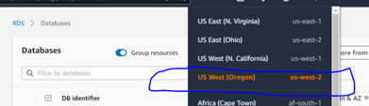
- In the navigation pane, choose Databases.
- Choose Create database and make sure that Standard Create is chosen.

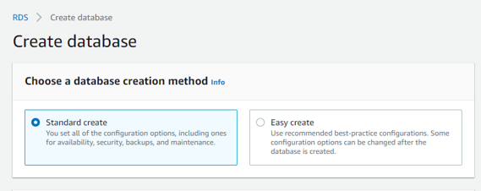
- In Configuration, choose PostgreSQL.
- For DB instance size, choose Dev/Test. 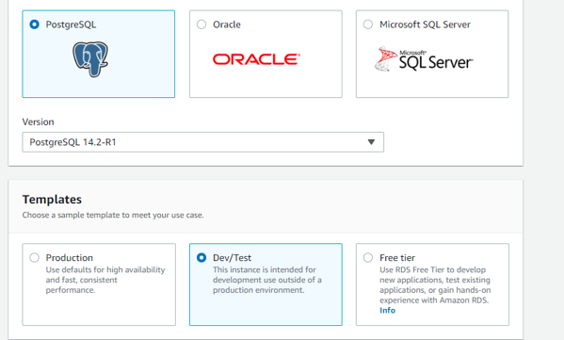
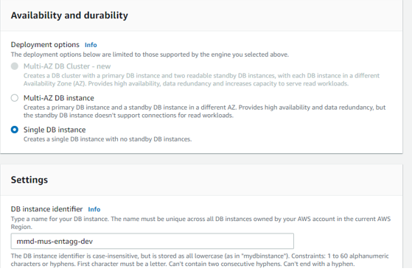

- For DB instance identifier, enter a name for the DB instance, or leave the default name.
- For Master username, enter a name for the master user, or leave the default name (postgres).
- Provide the password for postgres.
- Set for remaining default settings.
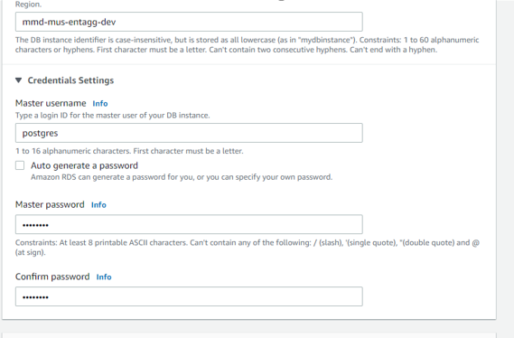
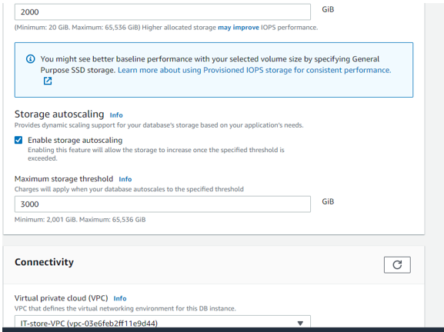
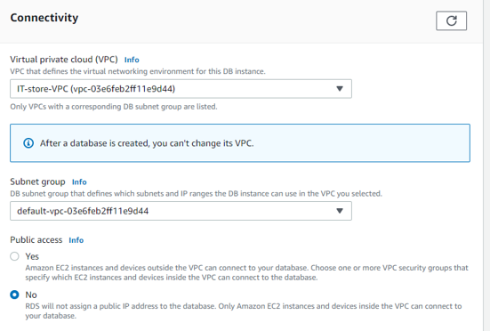
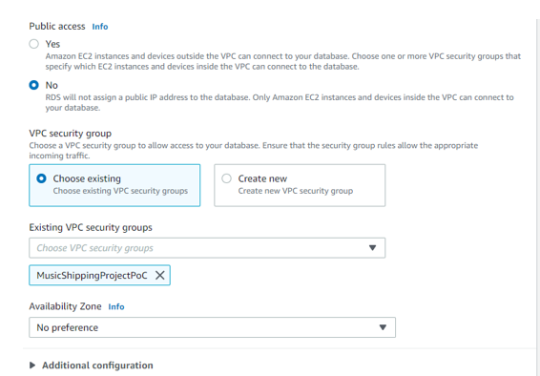
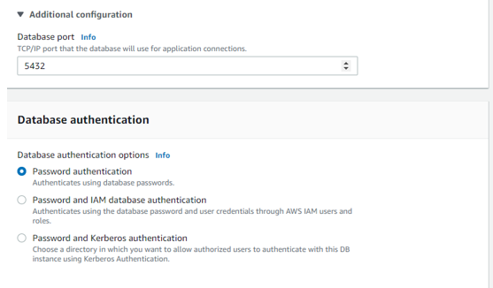
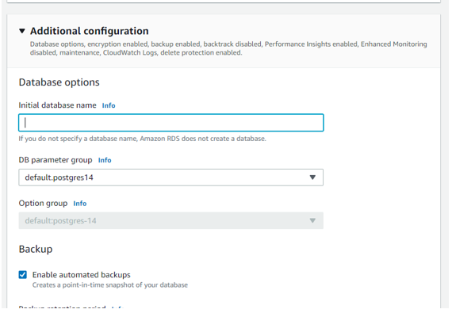
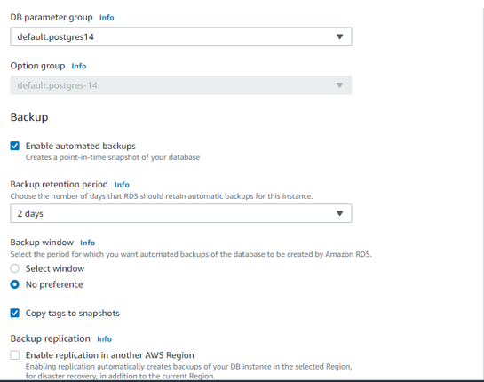
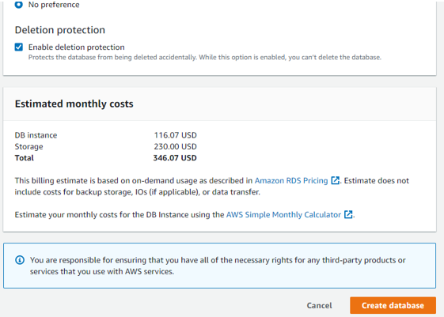
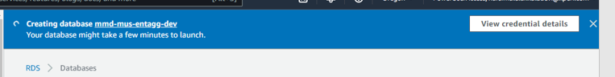

End points creation

Source Endpoint
The change capture process, used when replicating ongoing changes, collects changes from the database logs by using the database engines native API, no client-side install is required.
Each engine has specific configuration requirements for exposing this change stream to a given user account (for details, see the AWS Key Management Service documentation).
Most engines require some additional configuration to make the change data consumable in a meaningful way without data loss for the capture process

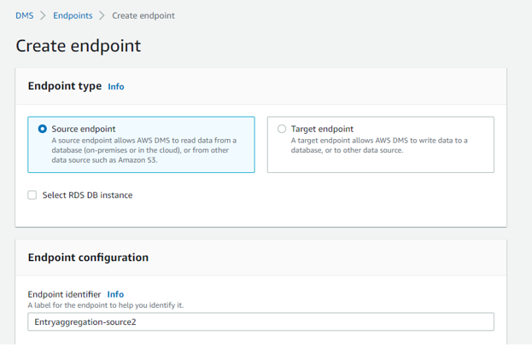
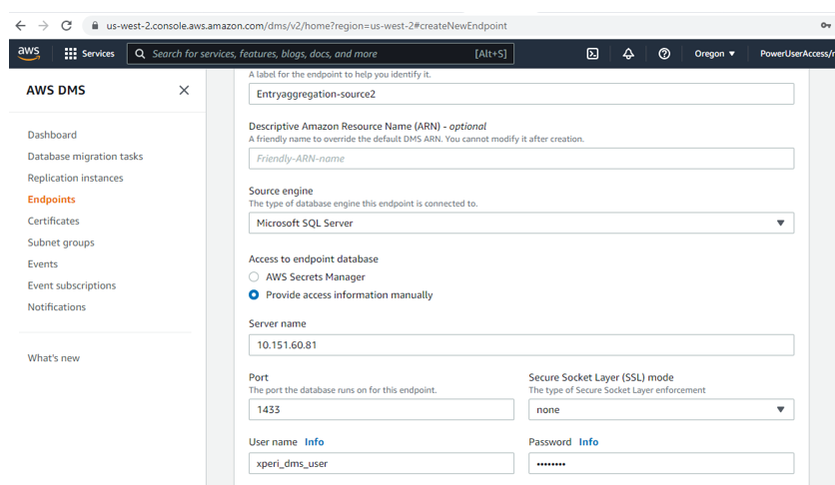
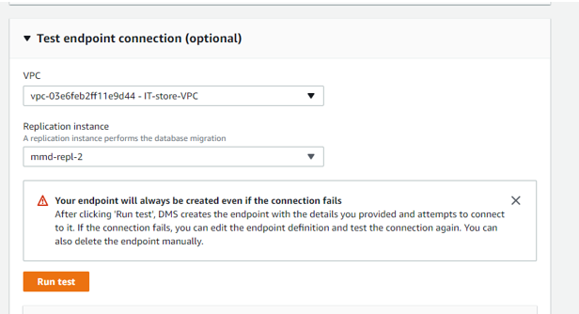
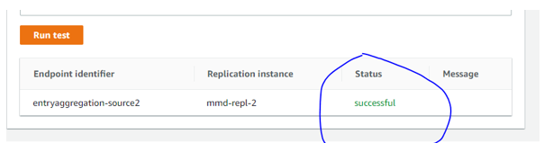

Target Endpoint
Whenever possible, AWS DMS attempts to create the target schema for we, including underlying tables and primary keys. However, sometimes this isn’t possible. For example, when the target is Oracle, AWS DMS doesn’t create the target schema for security reasons
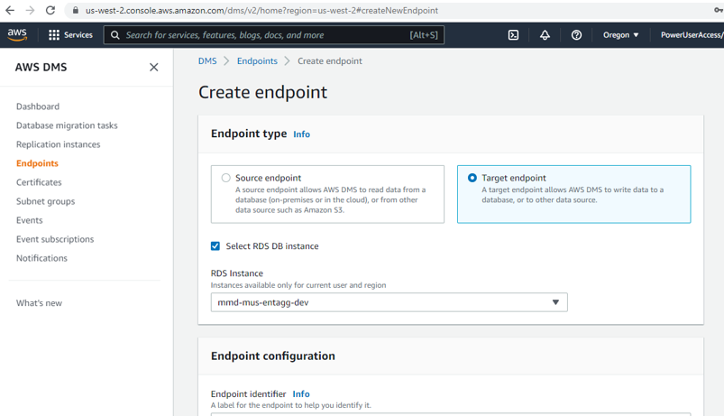
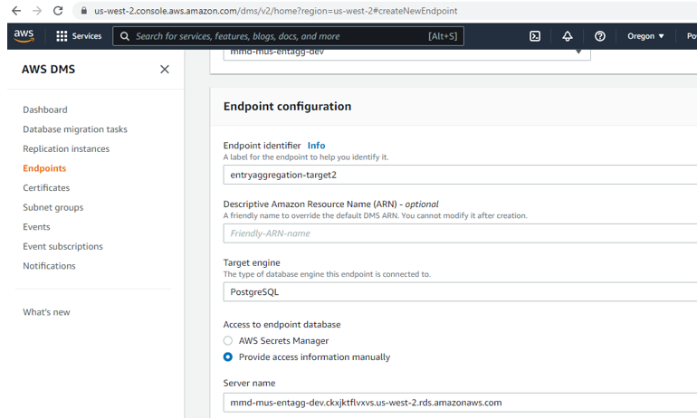
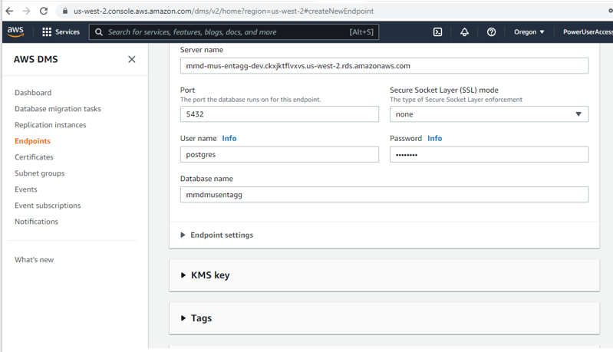
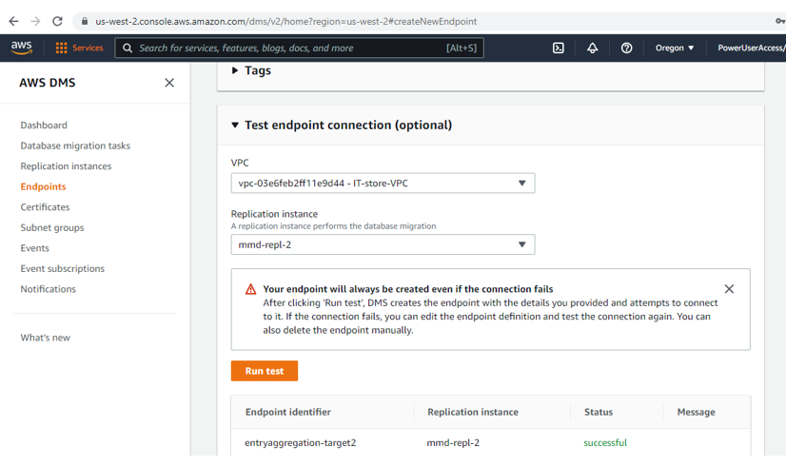

Database migration tasks -DMS
Migration Type:
Migrate existing data:
If we can afford an outage that’s long enough to copy our existing data, this is a good option to choose. This option simply migrates the data from our source system to our target, creating tables as needed.
Migrate existing data and replicate ongoing changes:
This option performs a full data load while capturing changes on the source. After the full load is complete, captured changes are applied to the target. Eventually, the application of changes will reach a steady state. At that point, we can shut down our applications, let the remaining changes flow through to the target, and restart our applications to point at the target.
Replicate data changes only:
In some situations, it may be more efficient to copy the existing data by using a method outside of AWS DMS. For example, in a homogeneous migration, using native export/import tools can be more efficient at loading the bulk data. When this is the case, we can use AWS DMS to replicate changes as of the point in time at which we started our bulk load to bring and keep our source and target systems in sync. When replicating data changes only, we need to specify a time from which AWS DMS will begin to read changes from the database change logs. It’s important to keep these logs available on the server for a period to ensure AWS DMS has access to these changes. This is typically achieved by keeping the logs available for 24 hours (or longer) during the migration process.
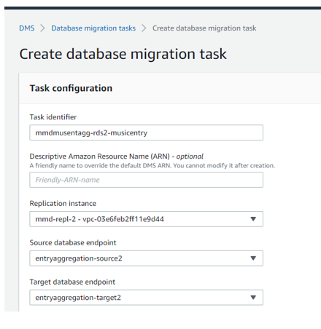
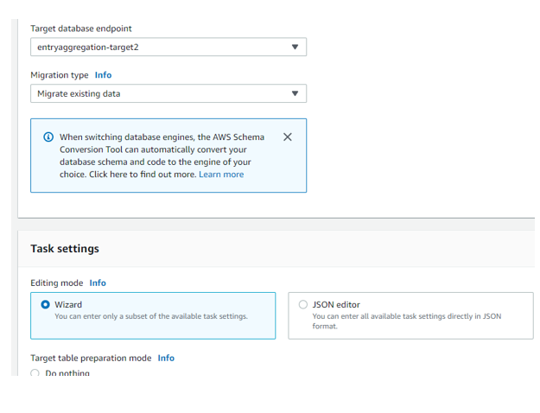
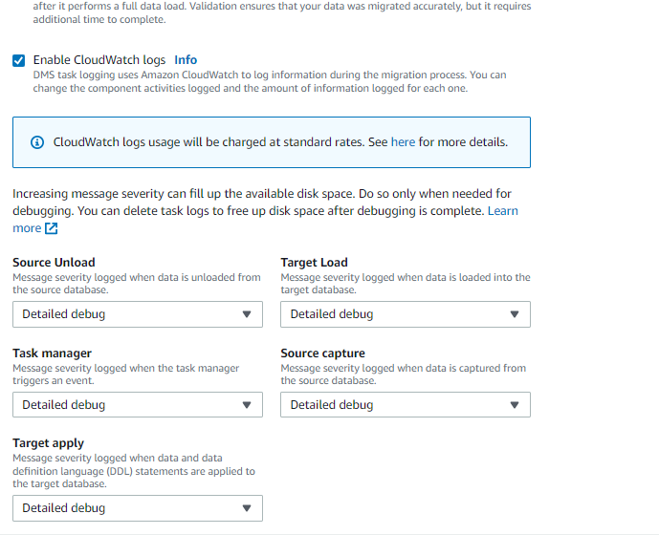
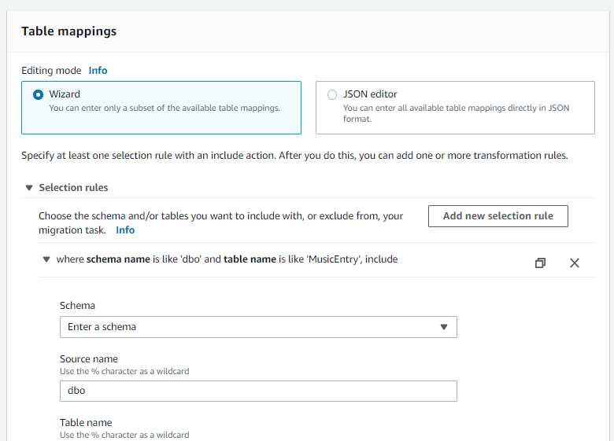
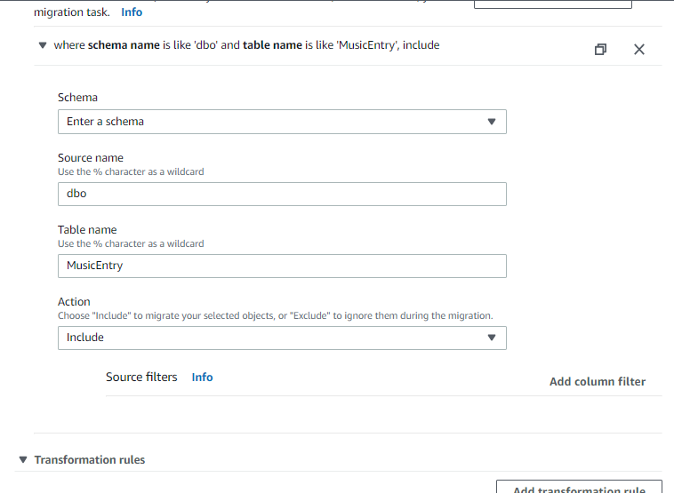
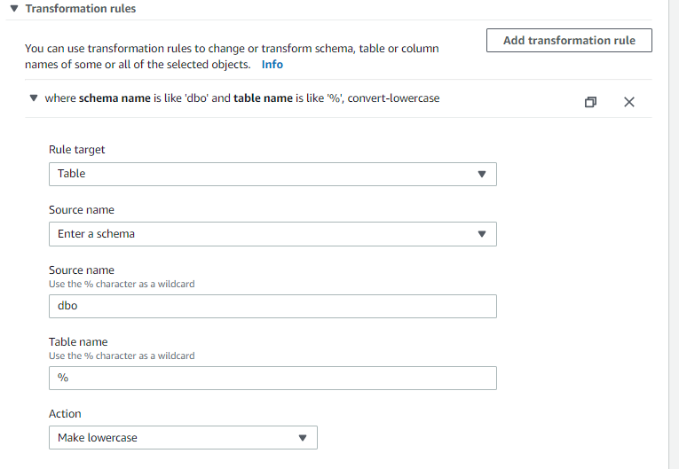
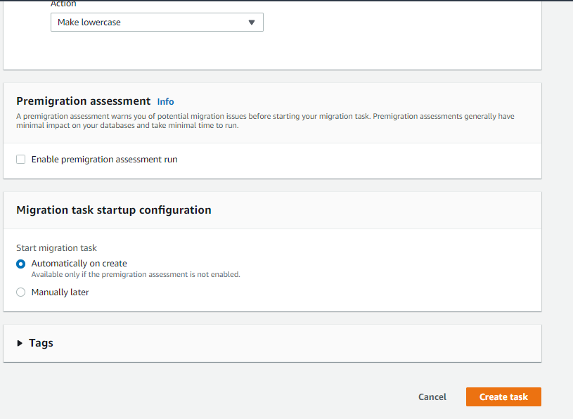

Start Task on Create
By default, AWS DMS will start our task as soon as we create it. In some situations, it’s helpful to postpone the start of the task. For example, using the AWS Command Line Interface (AWS CLI), we may have a process that creates a task and a different process that starts the task, based on some triggering event

Target Table Prep Mode
- Target table prep mode tells AWS DMS what to do with tables that already exist. If a table that is a member of a migration doesn’t yet exist on the target, AWS DMS will create the table.

- By default, AWS DMS will drop and recreate any existing tables on the target in preparation for a full load or a reload. If we’re pre-creating our schema, set our target table prep mode to truncate, causing AWS DMS to truncate existing tables prior to load or reload. When the table.

- prep mode is set to do nothing, any data that exists in the target tables is left as is. This can be useful when consolidating data from multiple systems into a single table using multiple tasks. AWS DMS performs these steps when it creates a target table.

- The source database column data type is converted into an intermediate AWS DMS data type.
- The AWS DMS data type is converted into the target data type. This data type conversion is performed for both heterogeneous and homogeneous migrations.

- In a homogeneous migration, this data type conversion may lead to target data types not matching source data types exactly. For example, in some situations it’s necessary to triple the size of varchar columns to account for multi-byte characters. We recommend going through the AWS DMS documentation on source and target data types to see if all the data types we use are supported.

- If the resultant data types aren’t to our liking when we’re using AWS DMS to create our objects, we can pre-create those objects on the target database. If we do pre create some or all our target objects, be sure to choose the truncate or do-nothing options for target table preparation mode.

LOB Controls
- Due to their unknown and sometimes large size, large objects (LOBs) require more processing and resources than standard objects. To help with tuning migrations of systems that contain LOBs, AWS DMS offers the following options:

Don’t include LOB columns:
- When this option is selected, tables that include LOB columns are migrated in full, however, any columns containing LOBs will be omitted.

Full LOB mode:
- When we select full LOB mode, AWS DMS assumes no information regarding the size of the LOB data.
- LOBs are migrated in full, in successive pieces, whose size is determined by the LOB chunk size. Changing the LOB chunk size affects the memory consumption of AWS DMS; a large LOB chunk size requires more memory and processing.

- Memory is consumed per LOB, per row. If we have a table containing three
LOBs, and are moving data 1,000 rows at a time, an LOB chunk size of 32 k will require
3*32*1000 = 96,000 k of memory for processing. Ideally, the LOB chunk size should be
set to allow AWS DMS to retrieve the majority of LOBs in as few chunks as possible. For
example, if 90 percent of our LOBs are less than 32 k, then setting the LOB chunk size
to 32 k would be reasonable, assuming we have the memory to accommodate the
setting.

Limited LOB mode:

- When limited LOB mode is selected, any LOBs that are larger than max LOB size are truncated to max LOB size and a warning is issued to the log file. Using limited LOB mode is almost always more efficient and faster than full LOB mode.
- We can usually query our data dictionary to determine the size of the largest LOB in a table, setting max LOB size to something slightly larger than this (don’t forget to account for multi-byte characters). If we have a table in which most LOBs are small, with a few large outliers, it may be a good idea to move the large LOBs into their own table and use two tasks to consolidate the tables on the target.
- LOB columns are transferred only if the source table has a primary key or a unique index on the table. Transfer of data containing LOBs is a two-step process: 1. The containing row on the target is created without the LOB data. 2. The table is updated with the LOB data. The process was designed this way to accommodate the methods source database engines use to manage LOBs and changes to LOB data.
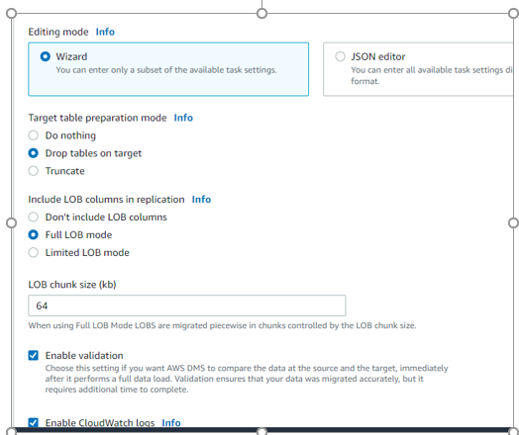

Enable Logging:
It’s always a good idea to enable logging because many informational and warning messages are written to the logs. However, be advised that we’ll incur a small charge, as the logs are made accessible by using Amazon CloudWatch.
Find appropriate entries in the logs by looking for lines that start with the following:
• Lines starting with “E:” – Errors
• Lines starting with “W:” – Warnings
• Lines starting with “I:” – Informational messages
We can use grep (on UNIX-based text editors) or search (for Windows-based text editors) to find exactly what we’re looking for in a huge task log.

Increasing Performance:
The performance of our migration will be limited by one or more bottlenecks we encounter along the way. The following are a few things we can do to increase performance.

Load Multiple Tables in Parallel
By default, AWS DMS loads eight tables at a time. We may see some performance improvement by increasing this slightly when we’re using a very large replication server; however, at some point increasing this parallelism will reduce performance. If our replication server is smaller, we should reduce this number.

Remove Bottlenecks on the Target
During the migration, try to remove any processes that would compete for write resources on our target database. This includes disabling unnecessary triggers, validation, secondary indexes, and so on. When migrating to an RDS database, it’s a good idea to disable backups and Multi-AZ on the target until we’re ready to cutover. Similarly, when migrating to non-RDS systems, disabling any logging on the target until cutover is usually a good idea.

Use Multiple Tasks
Sometimes using multiple tasks for a single migration can improve performance. If we have sets of tables that don’t participate in common transactions, it may be possible to divide our migration into multiple tasks.

Improving LOB Performance

Pay attention to the LOB parameters. Whenever possible, use limited LOB mode. If we have a table which consists of a few large LOBs and mostly smaller LOBs, consider breaking up the table into a table that contains the large LOBs and a table that contains the small LOBs prior to the migration. We can then use a task in limited LOB mode to migrate the table containing small LOBs, and a task in full LOB mode to migrate the table containing large LOBs.

Optimizing Change Processing

By default, AWS DMS processes changes in a transactional mode, which preserves transactional integrity. If we can afford temporary lapses in transactional integrity, we can turn on batch optimized apply. Batch optimized apply groups transactions and applies them in batches for efficiency purposes.

Reducing Load on Our Source System
During a migration, AWS DMS performs a full table scan of each source table being processed (usually in parallel). Additionally, each task periodically queries the source for change information. To perform change processing, we may be required to increase the amount of data written to our database’s change log. If we find we are overburdening our source database, we can reduce the number of tasks or tables per task of our migration. If we prefer not to add load to our source, consider performing the migration from a read copy of our source system.

